Descriptive / Semantic Markup

📌 Definition:
# Source: AI Source: Provided by: [Data Path: Persons Table -> ID Column: 1, Name_En Column: Motasem Essam] -> From: [ChatGPT] on [12/9/2025]
Semantic (Descriptive) markup is a type of markup that focuses on the meaning and structure of content, not how it looks.

🧠 Simple idea:
# Source: AI Source: Provided by: [Data Path: Persons Table -> ID Column: 1, Name_En Column: Motasem Essam] -> From: [ChatGPT] on [12/9/2025]
Semantic = “What it means” 💡

🔍 Key characteristics:
# Source: AI Source: Provided by: [Data Path: Persons Table -> ID Column: 1, Name_En Column: Motasem Essam] -> From: [ChatGPT] on [12/9/2025]
- 🧩 Describes meaning of content
- 🏗️ Defines structure (headings, paragraphs, sections)
- 🎯 Improves accessibility and SEO
- 🎨 Styling is handled separately (usually with CSS)

📌 Examples:
# Source: AI Source: Provided by: [Data Path: Persons Table -> ID Column: 1, Name_En Column: Motasem Essam] -> From: [ChatGPT] on [12/9/2025]
🌐 HTML (semantic tags)
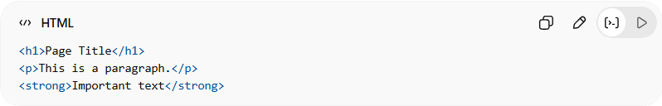
<h1>Page Title</h1>
<p>This is a paragraph.</p>
<strong>Important text</strong>
👉 These tags describe meaning:
- <h1> → main heading
- <p> → paragraph
- <strong> → important text

🏷️ More semantic HTML examples:
# Source: AI Source: Provided by: [Data Path: Persons Table -> ID Column: 1, Name_En Column: Motasem Essam] -> From: [ChatGPT] on [12/9/2025]
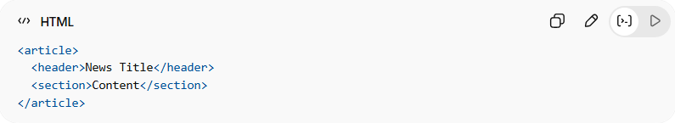
<article>
<header>News Title</header>
<section>Content</section>
</article>
👉 These describe structure of content, not appearance.

⚙️ Why it is important:
# Source: AI Source: Provided by: [Data Path: Persons Table -> ID Column: 1, Name_En Column: Motasem Essam] -> From: [ChatGPT] on [12/9/2025]
- ♿ Improves accessibility (screen readers understand it better)
- 🔍 Better SEO (search engines)
- 🧹 Cleaner and maintainable code

🆚 Semantic vs Presentational
# Source: AI Source: Provided by: [Data Path: Persons Table -> ID Column: 1, Name_En Column: Motasem Essam] -> From: [ChatGPT] on [12/9/2025]
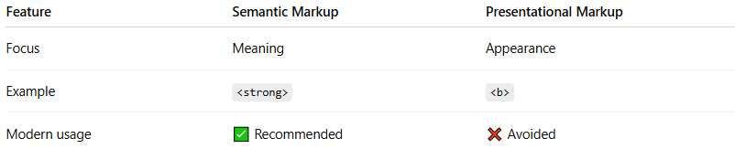
Feature | Semantic Markup | Presentational Markup
Focus | Meaning | Appearance
Example | <strong> | <b>
Modern usage | ✅ Recommended | ❌ Avoided

🎯 Summary:
# Source: AI Source: Provided by: [Data Path: Persons Table -> ID Column: 1, Name_En Column: Motasem Essam] -> From: [ChatGPT] on [12/9/2025]
Semantic markup describes the meaning and structure of content, making it clearer, more accessible, and easier to manage.

